Performance Task
Question. I “Scripting”
1- Develop a working JMeter script simulating a full user journey to be as follows:
1- Navigate to https://petstore.octoperf.com/actions/Catalog.action landing Page.
2- Click on the “Sign In” button the Click on “Register Now! “
3- fill all the fields with any data click save
4-Then click on Fish and click on the first Product ID
5- Then click on the First Item ID
6- Click on Add to cart button
7- Update the Quantity Make it 10
8- Then click on Update cart
9- Then click on “Proceed to checkout”.
9- Click Continue and Then Confirm
10- On the “Payment Method” page click on “Pay by bank wire”.
11- On the “Order Summary” page click on “I confirm my Order”.
12- Validate that the order has been Submitted by asserting on “Thank you, your order has been submitted.” On the “ORDER CONFIRMATION” Page.
2- Develop Jmeter Script That cover the flow of Apis
Go to this Link : https://restful-booker.herokuapp.com/apidoc/index.html#api-Auth-CreateToken
1- Make Post request https://restful-booker.herokuapp.com/auth
2- Then Create A Booking Make A Post Request : https://restful-booker.herokuapp.com/booking
3- Then Get all the Booking id MAke a Get Request : https://restful-booker.herokuapp.com/booking
4- Then Update the book , extract the ID which = 1 by getting the value from the previous request (use Regex or Json Extractor) Make a Put Request : https://restful-booker.herokuapp.com/booking/${{id}}
5- then check if the ID ==1 Make Delete Request : https://restful-booker.herokuapp.com/booking/${{id}}

Script quality will be judged as follows:
1- The correct use of parameterization, try as much as you can to make your script fully independent of test data. By replacing hardcoded values on each request by a user defined variable and CSV.
2- Adding assertion for each response to validate the correct user navigation through the different pages. Make it a text response assertion not a response code.
3- Make your script independent of the running environment by using HTTP Request Defaults.
4- Use Constant Timers with reasonable delays therefore, we can have a more realistic script. 5- User Cache manager forces it to clear cache for each iteration.
6- Feel free to use Cookie manager when needed.
Delivery:
Name your project file as “JMeter_Assignment.jmx” and upload it alongside the (Test_Data.csv) file. And attach them to the mail thread where I sent you this task.
Question. II “Running and Analyzing”
For the already developed script in Question. I add a Simple “Thread Group”, an “Aggregate Report”, make a full performance run with 2 users for 10 mins If you make a Two Thread Group Run them sequential separated , watch your “Aggregate Report” counting and accumulating the results and when it’s done take a screenshot for that aggregate report.
Validate your obtained results against these SLAs:
1- The total error percentage for all samples must not exceed (10 %).
2- At least 90% of the total issued requests must not exceed (3 seconds).
3- At least 99% of requests must not exceed (5 seconds).
Delivery:
A pdf file (Report.pdf) where your aggregate report screenshot is placed; also add a 3-rows table in the same document. Each row shall represent the status for each SLA mentioned above. Shade any violated SLA(s) in Red. And the passed ones in Green.
Note : Please stick to two users and don’t apply a large load on the system otherwise you may end up having all your IPs blacklisted by the site owner and we will no longer have access to it.

Question. III “Load Profiling”:
A. Use the “jp@gc - Stepping Thread Group” that we have covered in our session to configure the following load profile:
Ramping up 100 users at a pace 1 user/second and ramp down with an exit rate of 1 user/second. The Load Profile should be looking like the following:
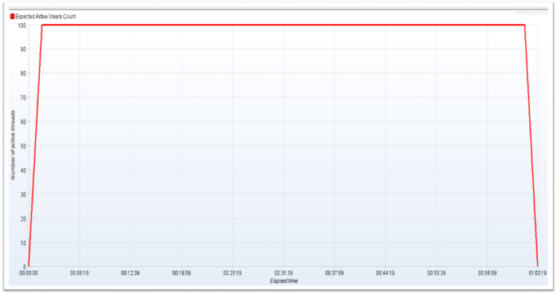

B. (Bonus Question) Not a mandatory question !
Use JMeter to generate the following Load Profile having two spikes:
- The normal applied load is 60 users with a ramp rate = 1 user/ second and hold time = 600 seconds and a ramp down rate of 1 user/second
- Spike A should be suddenly starting by adding 60 additional users to the system while it is under load, the spike should start 120 seconds after the test start, with a ramp rate of 10 users/seconds and a ramp down rate of 10 users/seconds.
- Spike B should similar to Spike A with the exception that it should be applied 360 seconds after the test start.
Now how are you going to configure that load profile?
using "jp@gc - Ultimate Thread Group" you will have to read about it, as we did not cover it in our previous session. ☺

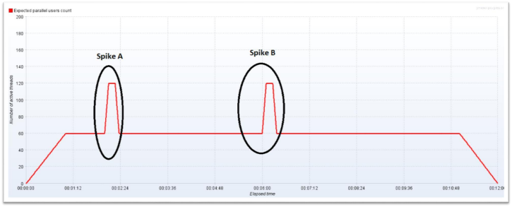

c. (Bonus Question) Not a mandatory question !
- Use K6 recorder to Implement The First Script

Delivery:
Just Send the two load profiles each in a separate file, (First_Load.jmx) and (Second_Load.jmx). For the load profile questions, Do not add components, do not record anything, do not run anything, just add thread groups, configure, save and send that is all.
Deadline : 8/3/2025
All the best of luck! Farah.Alaa Email : farahalaacis2014@gmail.com

